  Application Report:13  Producing water based coatings under final dissolving with a Fristam Shear Pump. |  | Shear Pumps
from: | Matthias Opitz  mail: Matthias.Opitz@Fristam.de  phone: +49 40 725 56-127 | date: | 29. June 2007

Application: | Producing coloured water based coatings under a final dissolving with a Fristam Shear Pump  Our customer (Brillux in Münster Germany) is one of Europeans largest producer of paint and coatings for house painting.  In case of high solid coloured paints there is a risk of “rub out”. That means, that pigments will settle down in the wet paint film and will change the colour.  Then the paint needs high shear to deagglomertate the and wet the single colour particles. The target was a particle size smaller than 10µm.

Used equipment: | Fristam Shear Pump FSPE 3532, 30 kW max. speed 5.500 rpm.  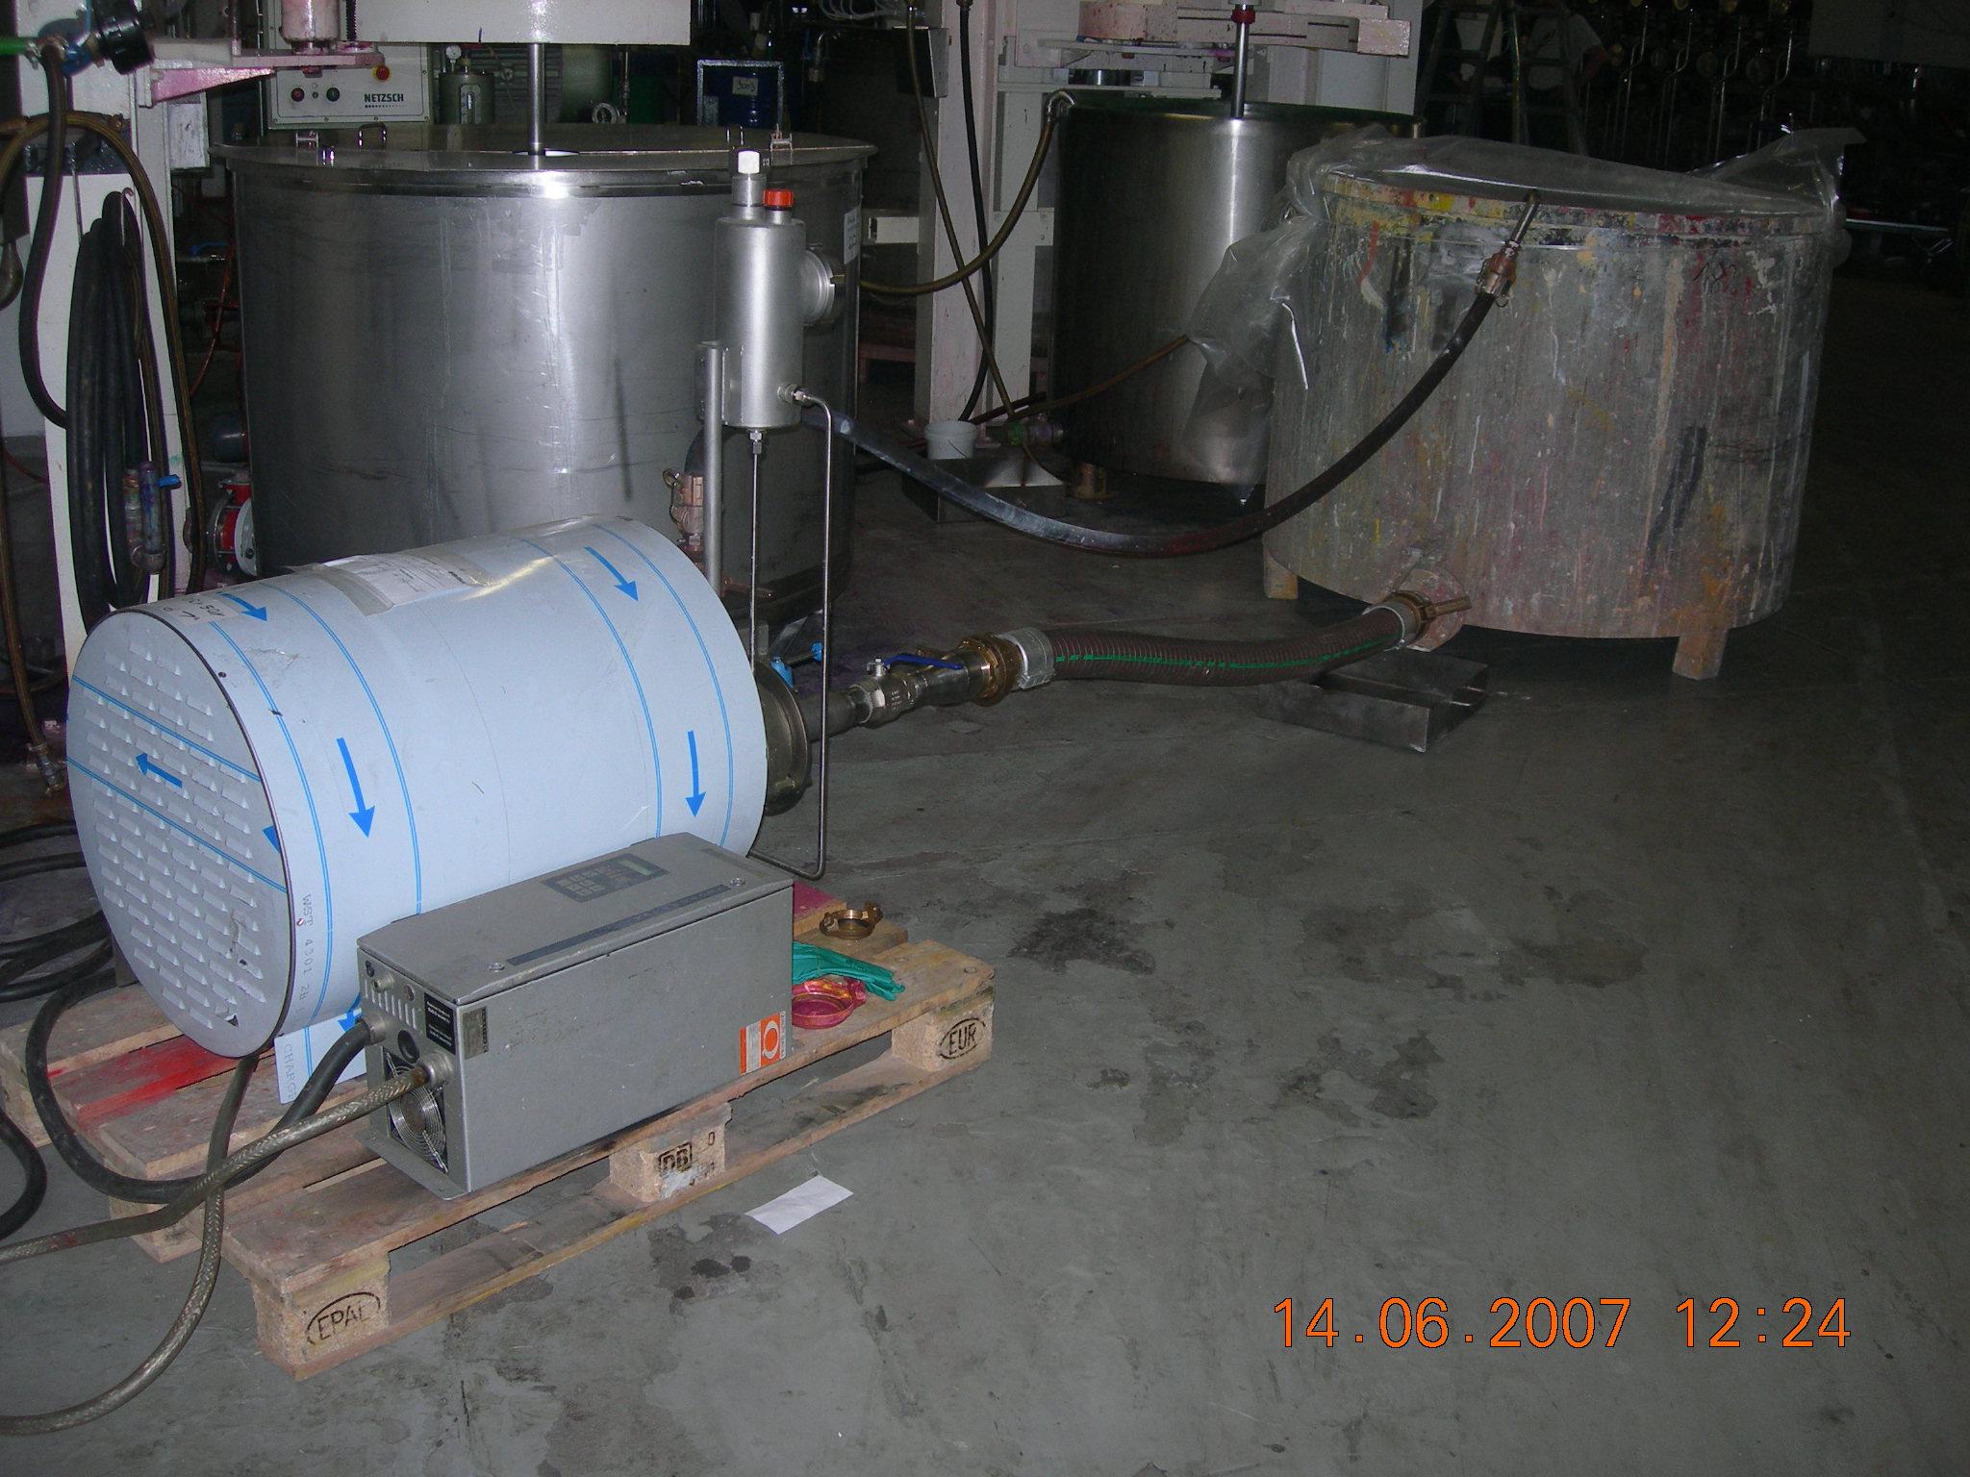  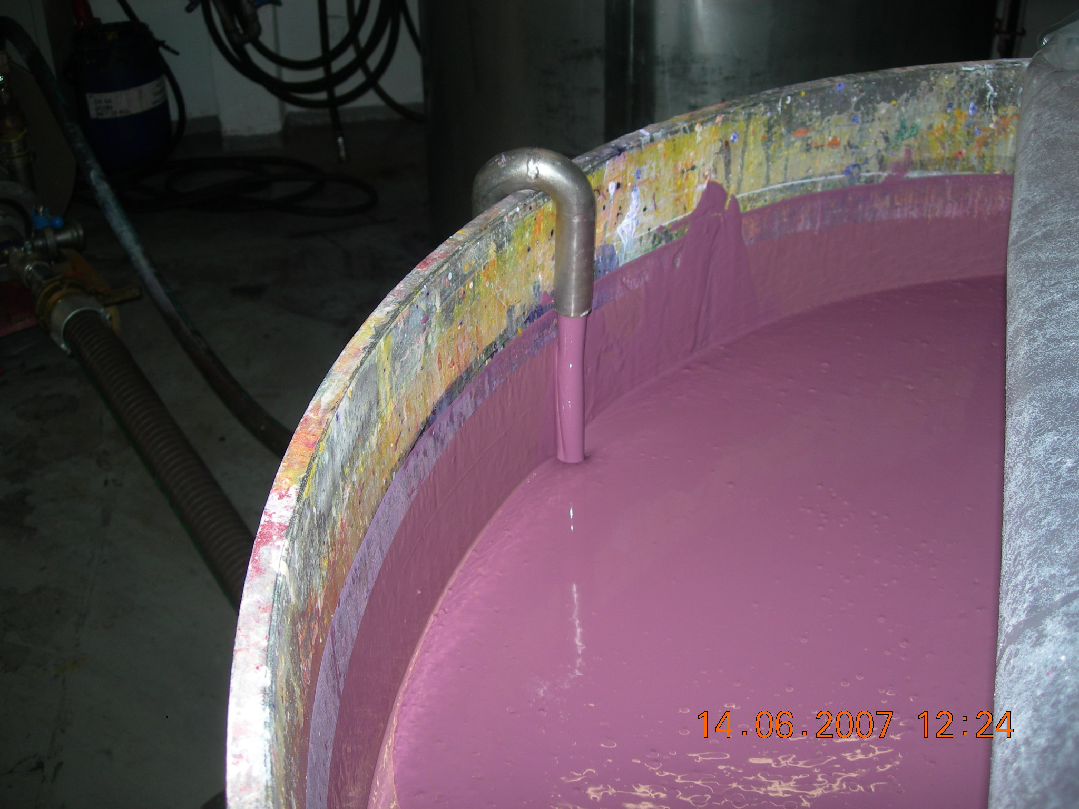  We recalculated the paint over the shear pump for three times. After this the “rub out” was eliminated.  We created a product with an absolute homogenous and smooth surface on coated test boards.  The next application was to add the colour paste into the base paint with our introducer vale, to reach verry quick a homogenous coloured paint.  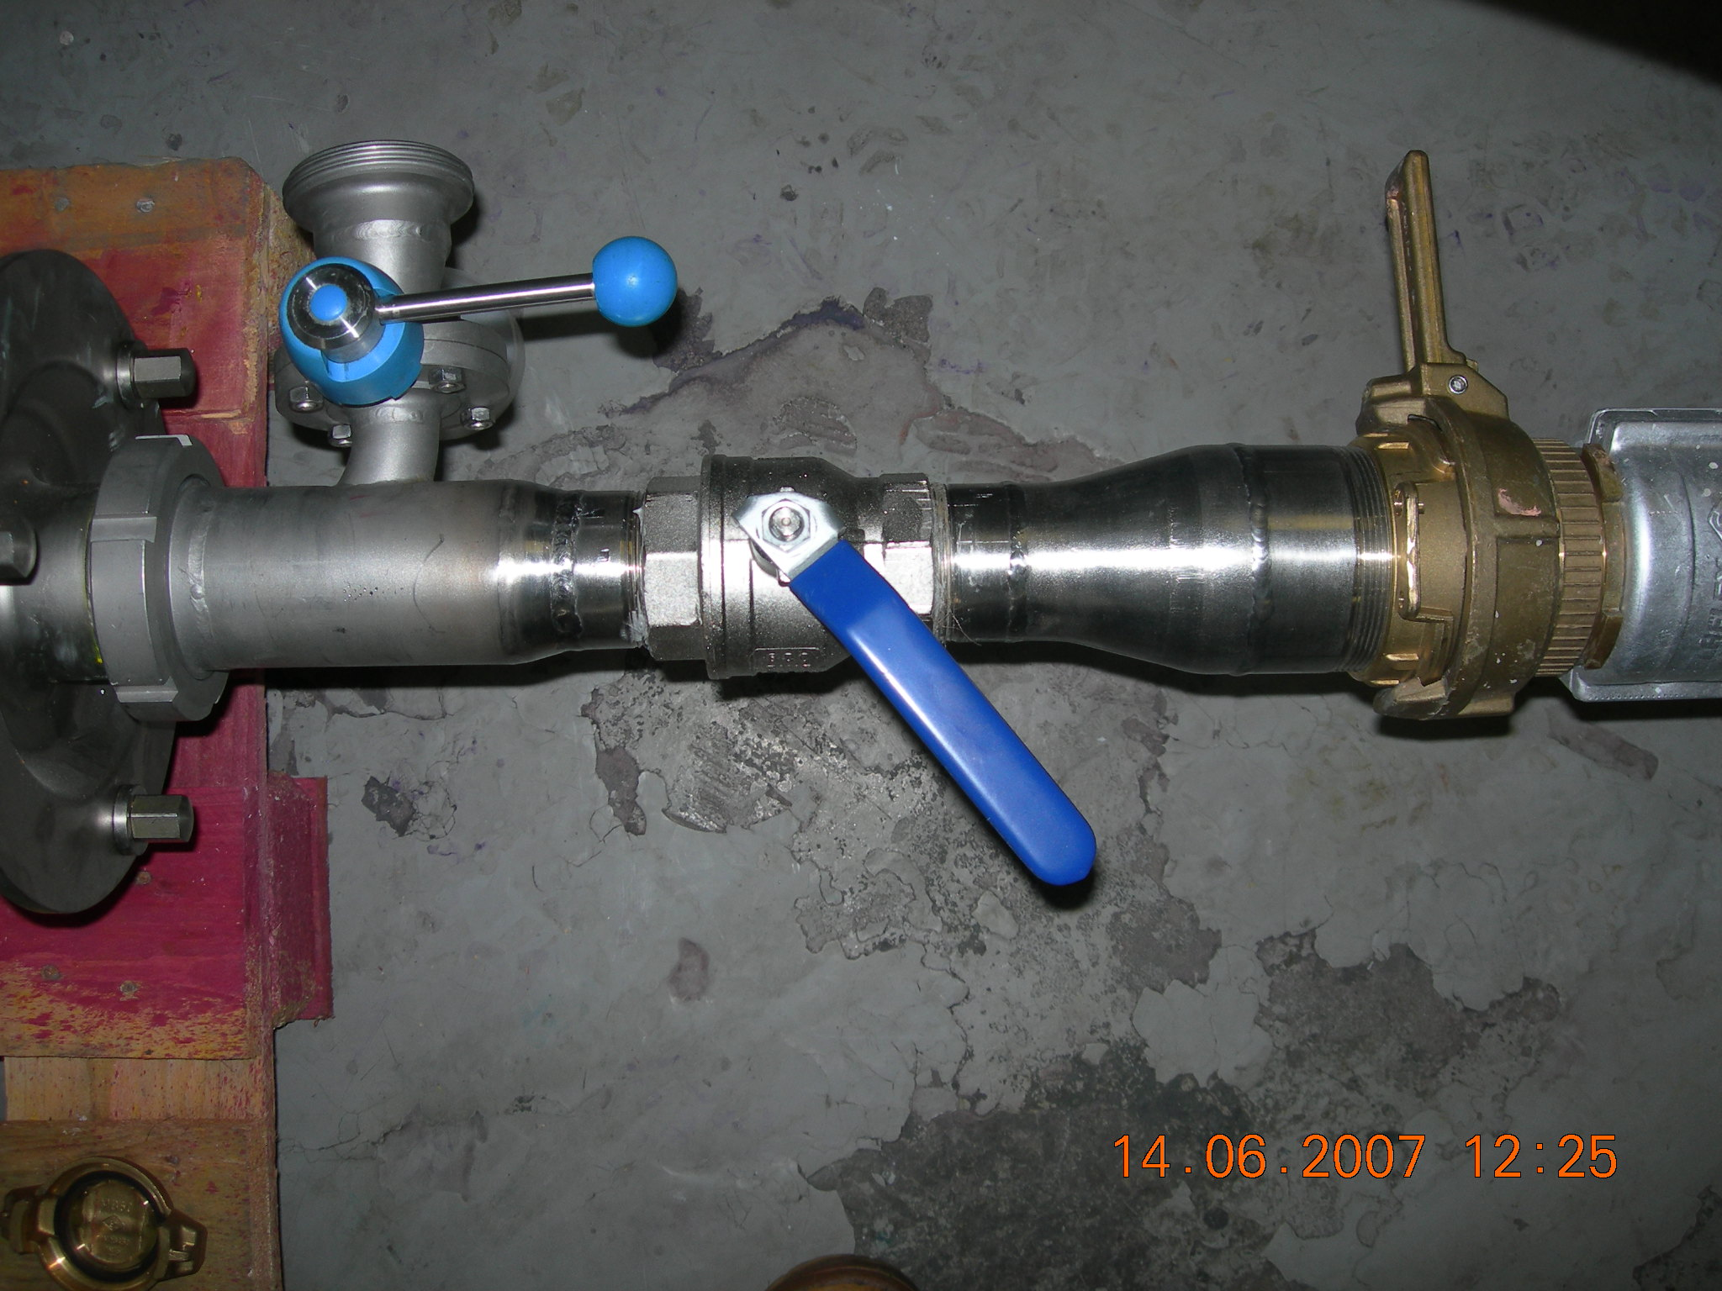

Result: | The customer is convinced from system !  The product quality was excellent !  Brillux bought the test unit directly after the tests.
Potential costumer in your sales area: | Please try to find out, if you have companies for paint and coatings in your sales area  Report about our successful application and offer a test.
Please contact us for additional information and report your experience.
Best regards
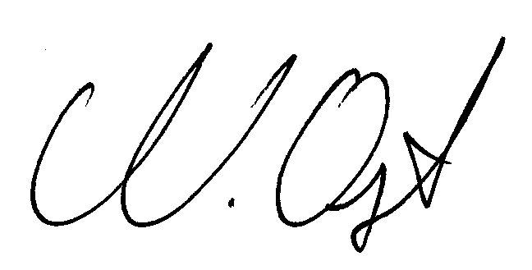
Matthias Opitz

